

Muğla Sıtkı Koçman University

EEE-3004 – Microprocessors

**GROUP PROJECT**

Ahmad Zameer Nazarı – *220702706*

Ahmed Mahmoud Elsayed Hussein – *220702705*

Fevzi Keshta – *210702725*

Mohamed Shawki Eid Elsayed Nejm – *210702723*

16th May 2025

Gesture Detection-Based Security System

*With Arduino Uno, OpenCV & Mediapipe*

# **Contents**

Contents 3

Overview 4

System 5

Components 5

Schematic 6

Assembly 7

Programming 8

Operation 13

Demonstration 14

# Overview

This project implements a gesture-based security system using computer vision and Arduino hardware. By combining face detection and hand gesture recognition, the system identifies a user’s presence, then authenticates them through a sequence of finger gestures as a password.

A python script processes video in real-time using the OpenCV library and handles face and gesture recognition using Google’s open-source machine learning framework, Mediapipe, while communication with an Arduino microcontroller controls LEDs and an LCD display to guide the user through each stage of interaction.

The project developed is a rudimentary implementation of a security system using object detection and recognition technology backed by machine learning, exploring novel ways for non-traditional security systems.

# System

## Components

The hardware components used in the project:

* Arduino Uno R3 for the microcontroller
* 16x2 Liquid Crystal Display (LCD) to display state messages
* 4x LEDs in colors blue, yellow, green and red to indicate different stages
* 5x resistors to properly ground some components
* potentiometer to adjust LCD contrast
* Breadboard to assemble all the components
* Some jumper wires for connections, and a USB A-B cable to facilitate connection between a computer and the microcontroller
* A computer with a camera.

Programs and libraries used are:

* The Arduino IDE, using C++ to program the sketch to be uploaded to the Arduino microcontroller.
* An IDE (Visual Studio Code was used) to write the python script that
* The OpenCV python library that processes video fed by the computer’s camera
* Google’s Mediapipe python library that detects gesture recognition by detecting face and hands
* The serial module allowing python to communicate with the Arduino via USB serial port.

### Schematic

Here is the circuit schematic of the system:

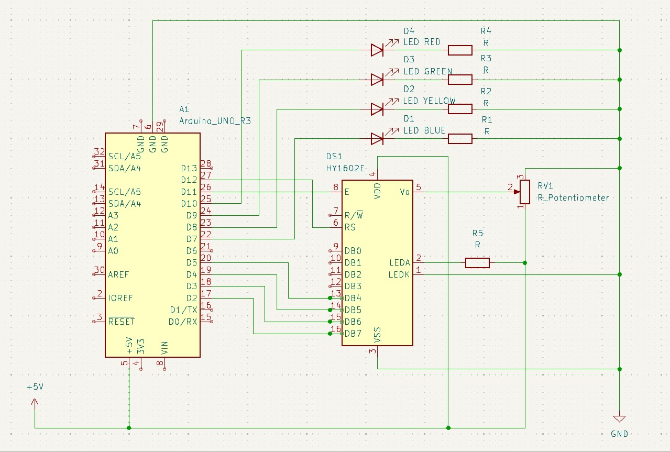

### Assembly

Here is the assembled microcontroller system:

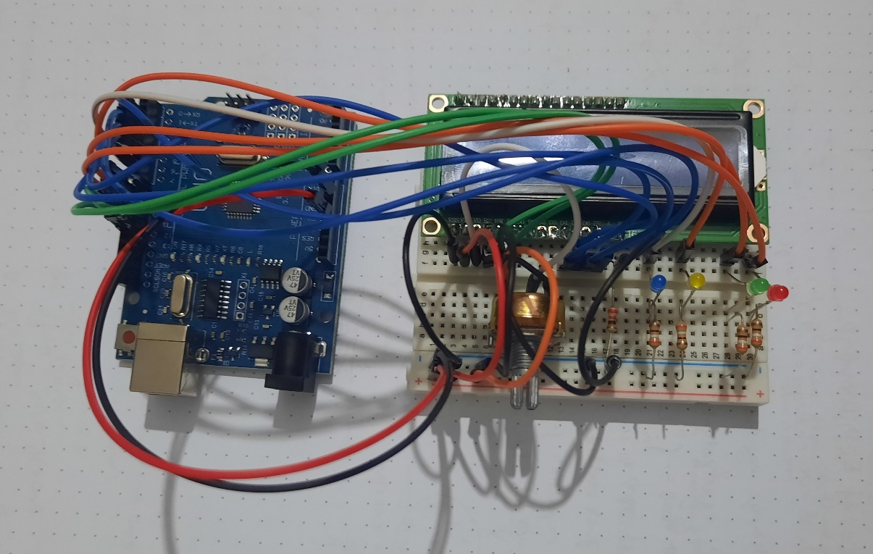

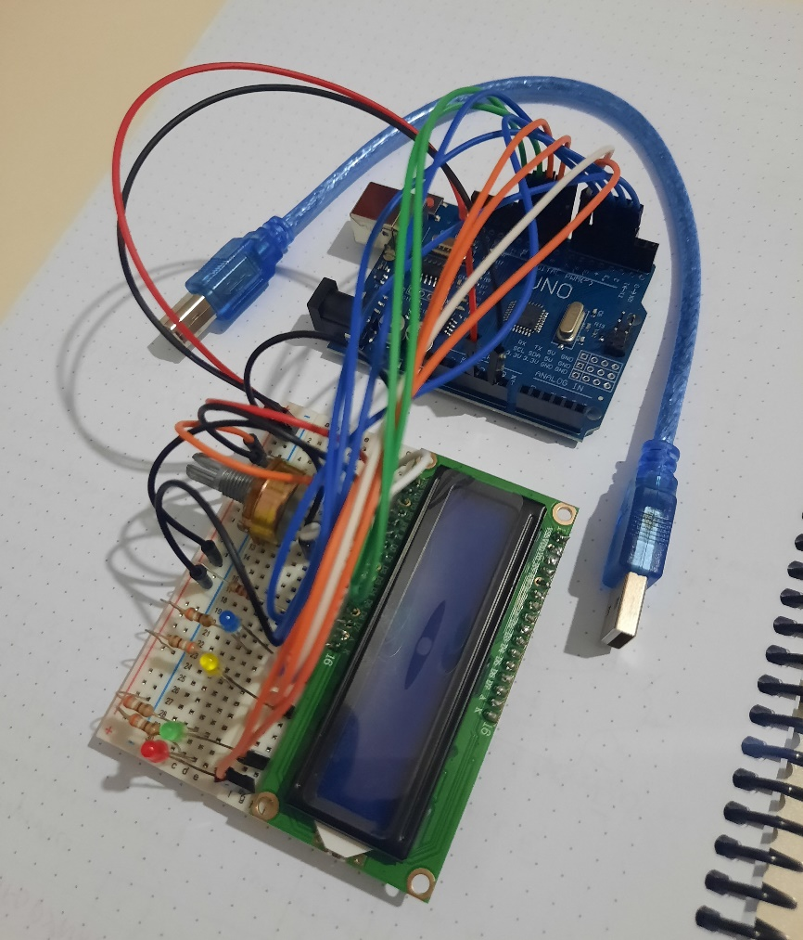

### Programming

The C++ code that was programmed to the Arduino microcontroller in the Arduino IDE is as follows:

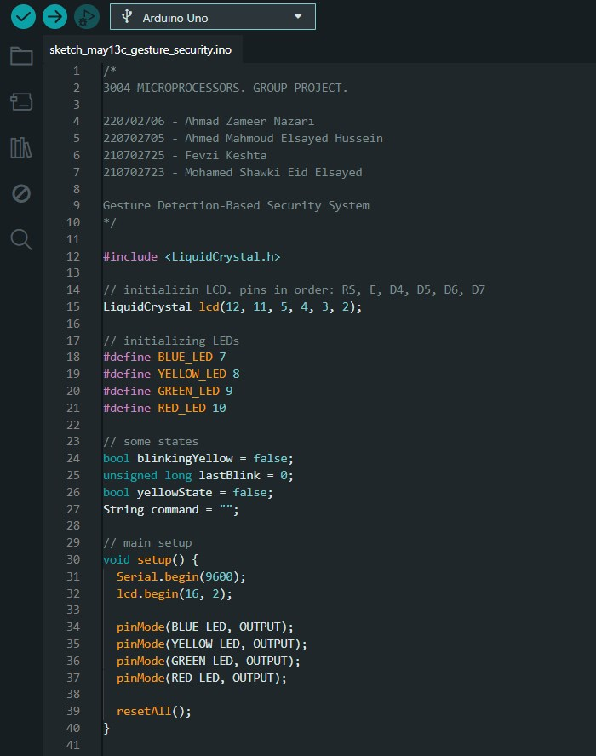

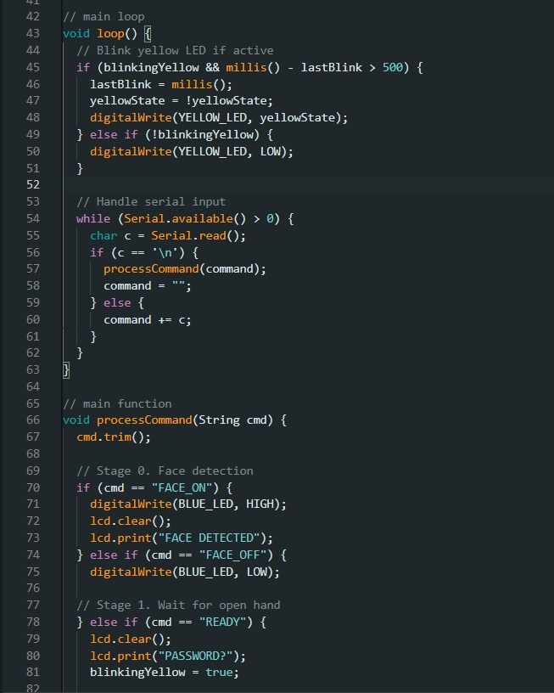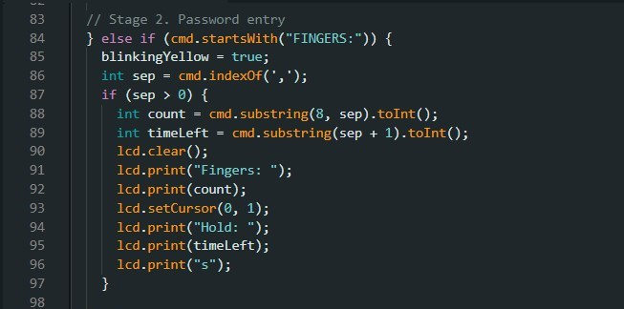

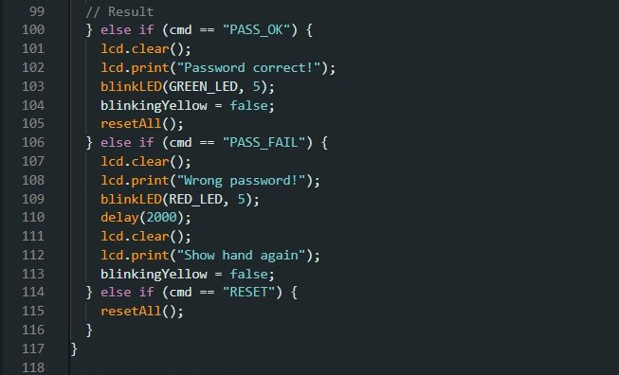

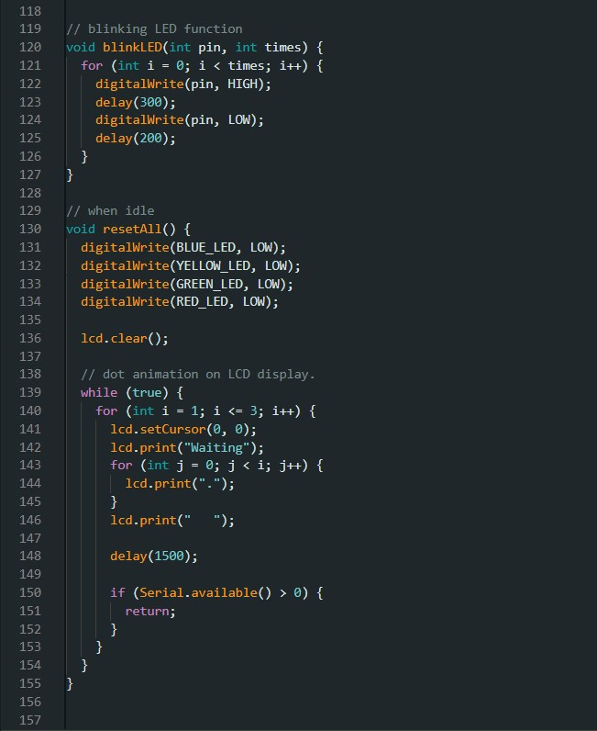

The Python script handling facial-detection and gesture-recognition is provided below:

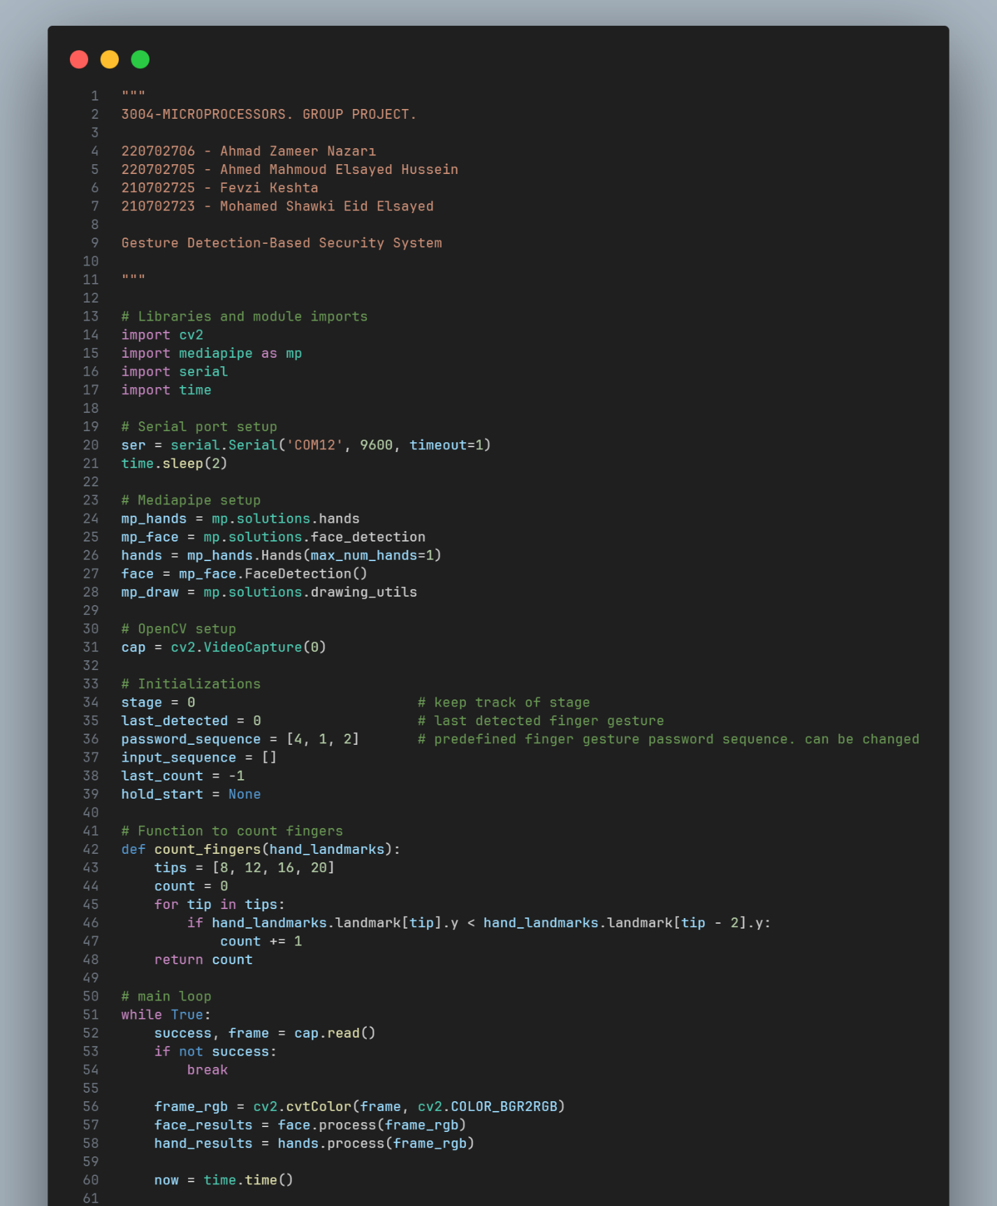

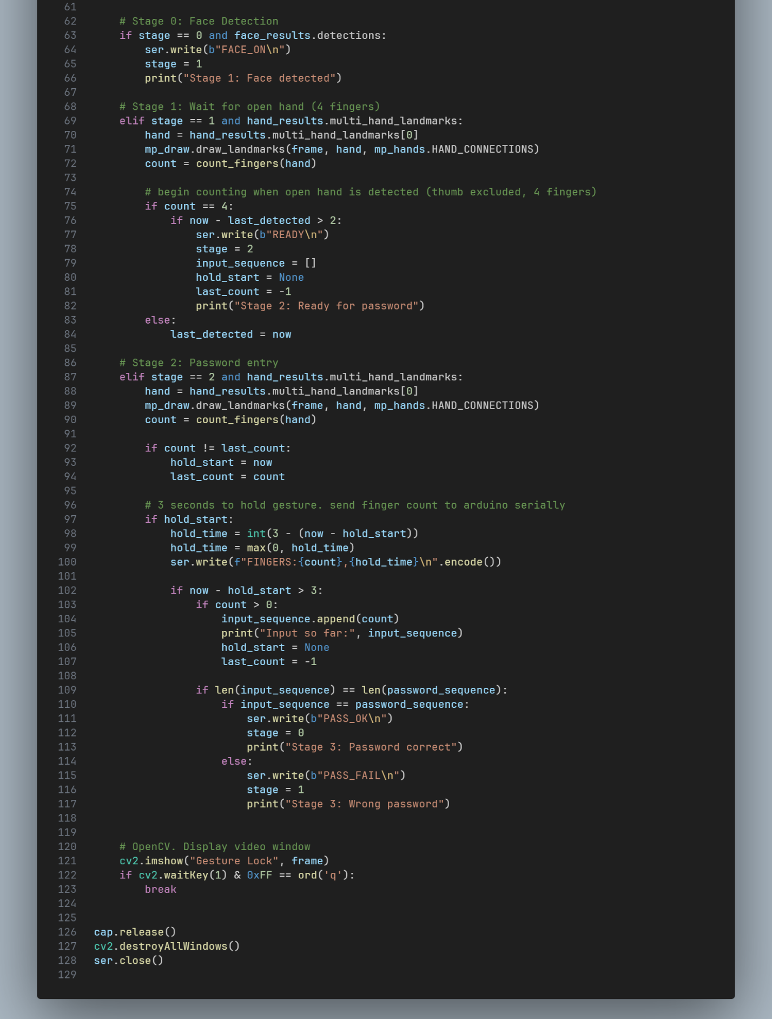

### Operation

The entire system operation is divided into three principal stages.

#### Stage 0:

The system is first in the pending stage, waiting for a person to come into the camera view. The LCD displays “Waiting…”

#### Stage 1:

When a person comes into view, a face is detected, and the system moves to Stage 1. The blue LED turns on, and the LCD displays the text, “Face Detected” The user is prompted to show an open palm with all five fingers visible. Holding this gesture for a few seconds, the system transitions to password mode.

#### Stage 2:

At this stage, a yellow LED starts blinking and the LCD prompts “Password?”

The user is requested to input a predefined sequence of finger counts (e.g. 4, 1, 2), each held for a duration of a few seconds.

If the sequence is correct, a green LED blinks and the LCD displays “Password Correct!”. If incorrect, a red LED blinks, the LCD displays “Wrong Password!” and the system resets, waiting for the open-palm gesture again.

### Demonstration

A video demonstrating the system has been uploaded to YouTube with the following URL:

<https://youtu.be/pU1nFCVVoqo>

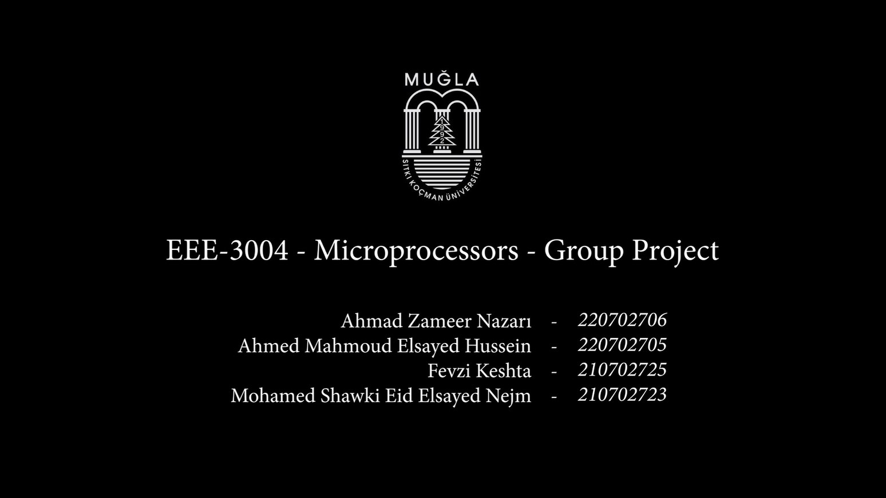

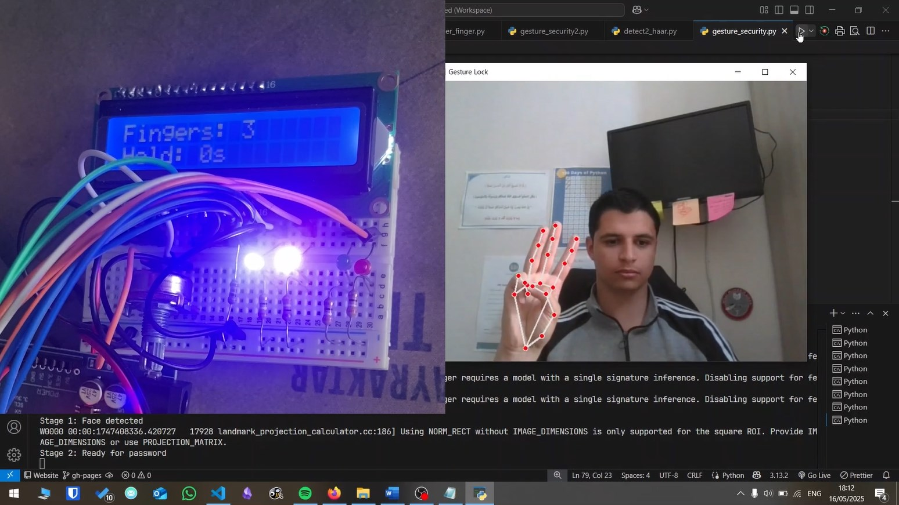

All files available at the repository:

https://github.com/az-yugen/EEE-3004-Microprocessors